RESOLUTION NO. SARDA 2025-
A RESOLUTION OF THE BOARD OF DIRECTORS OF THE SUCCESSOR AGENCY TO THE TEMECULA REDEVELOPMENT AGENCY APPROVING A RECOGNIZED OBLIGATION PAYMENT SCHEDULE FOR THE PERIOD OF JULY 1, 2025, THROUGH JUNE 30, 2026 PURSUANT TO HEALTH AND SAFETY CODE SECTION 34177 AND TAKING CERTAIN ACTIONS IN CONNECTION THEREWITH
THE BOARD OF DIRECTORS OF THE SUCCESSOR AGENCY TO THE TEMECULA REDEVELOPMENT AGENCY DOES HEREBY RESOLVE AS FOLLOWS:

Recitals. The Board of Directors of the Successor Agency to the Temecula Redevelopment Agency does hereby find, determine and declare that:

The Redevelopment Agency of the City of Temecula was a redevelopment agency in the City of Temecula, duly created pursuant to the Community Redevelopment Law, Part 1, commencing with Section 33000, of Division 24 of the California Health and Safety Code (hereafter the “Temecula Redevelopment Agency”). On June 12, 1988, the Board of Supervisors of the County of Riverside adopted Ordinance No. 658 adopting and approving the "Redevelopment Plan for Riverside County Redevelopment Project No. 1988-1." On December 1, 1989, the City of Temecula was incorporated. The boundaries of the Project Area described in the Plan are entirely within the boundaries of the City of Temecula. On April 9, 1991, the City Council of the City of Temecula adopted Ordinances Nos. 91-08, 91-11, 91-14, and 91-15 establishing the Redevelopment Agency of the City of Temecula and transferring jurisdiction over the Plan from the County to the City. Pursuant to Ordinance Nos. 91-11 and 91-15, the City of Temecula and the Redevelopment Agency of the City of Temecula assumed jurisdiction over the Plan as of July 1, 1991. The Plan has been amended by Ordinance Nos. 94-33, 06-11 and 07-20 adopted by the City Council.

The City Council of the City of Temecula adopted Resolution No. 12-02 January 10, 2012, pursuant to Health and Safety Code Section 34173 and applicable law electing for the City to serve as the Successor Agency for the Temecula Redevelopment Agency upon the dissolution of the Redevelopment Agency of the City of Temecula. The City Council of the City of Temecula, acting as the Governing Body for the Successor Agency to the Temecula Redevelopment Agency, adopted Resolution No. 12-01 on February 28, 2012 declaring the Successor Agency to the Temecula Redevelopment Agency duly constituted pursuant to law and establishing rules and regulations for the operation of the Successor Agency to the Temecula Redevelopment Agency (“Successor Agency”).

Pursuant to Health and Safety Code Section 34175(b) and the California Supreme Court’s decision in California Redevelopment Association, et al. v. Ana Matosantos, et al. (53 Cal.4th 231(2011)), on February 1, 2012, all assets, properties, contracts, leases, books and records, buildings, and equipment of the former Temecula Redevelopment Agency transferred to the control of the Successor Agency by operation of law.

Pursuant to Health and Safety Code Section 34177(o), the Successor Agency must prepare a Recognized Obligation Payment Schedule listing the anticipated payments for enforceable obligations to be made by the Successor Agency during the fiscal period from July 1, 2025 through June 30, 2026 (ROPS 25-26) and submit ROPS 25-26 to the Riverside County Oversight Board of the Successor Agency (the “Oversight Board”) for approval.

Accordingly, the Board desires to adopt this Resolution approving the ROPS 25-26.

This Resolution is adopted pursuant to Health and Safety Code Section 34177.

The Board hereby approves ROPS 25-26 substantially in the form attached as Exhibit A to this Resolution and incorporated herein by reference (the “ROPS”). The Executive Director of the Successor Agency, in consultation with the Successor Agency’s legal counsel, may modify the ROPS 25-26 as the Executive Director or the Successor Agency’s legal counsel deems necessary or advisable.

The Board hereby designates the Finance Director as the official to whom the DOF may make requests for review in connection with the ROPS 25-26 and who shall provide the DOF with the telephone number and e-mail contact information for the purpose of communicating with the DOF.

Staff is hereby authorized and directed to post a copy of the Oversight Board-approved ROPS 25-26 on the Successor Agency’s website.

The officers and staff of the Successor Agency are hereby authorized and directed, jointly and severally, to do any and all things which they may deem necessary or advisable to effectuate this Resolution, including submitting the ROPS 25-26 to the oversight board for approval and requesting additional review by the DOF and an opportunity to meet and confer on any disputed items, and any such actions previously taken by such officers are hereby ratified and confirmed.

The Secretary shall certify to the adoption of this Resolution.

PASSED, APPROVED, AND ADOPTED by the Board of Directors of the Successor Agency to the Temecula Redevelopment Agency this 14th day of January, 2025.
Brenden Kalfus, Chair
ATTEST:
Randi Johl, Secretary
[SEAL]

STATE OF CALIFORNIA |  |  | )
COUNTY OF RIVERSIDE |  |  | ) ss
CITY OF TEMECULA |  |  | )
I, Randi Johl, Secretary of the Successor Agency to the Temecula Redevelopment Agency, do hereby certify that the foregoing Resolution No. SARDA 2025- was duly and regularly adopted by the Board of Directors of the Successor Agency to the Temecula Redevelopment Agency at a meeting thereof held on the 14th day of January, 2025, by the following vote:
AYES: |  | BOARD MEMBERS:
NOES: |  | BOARD MEMBERS:
ABSTAIN: |  | BOARD MEMBERS:
ABSENT: |  | BOARD MEMBERS:
 |  |  |  | Randi Johl, Secretary

EXHIBIT A

Recognized Obligations Payment Schedule (ROPS) for the period
July 1, 2025 through June 30, 2026 (ROPS 25-26)

Successor Agency to the Temecula Redevelopment Agency (SARDA) 2025-26 ROPS

2025-26 ROPS Summary
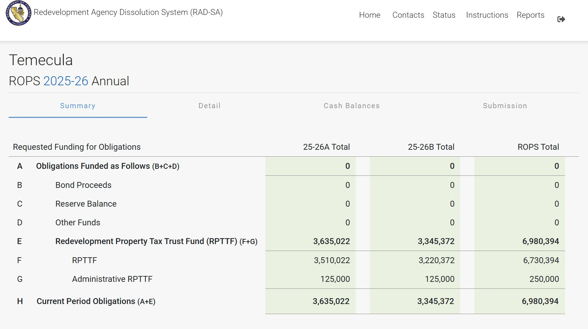

2025-26 ROPS
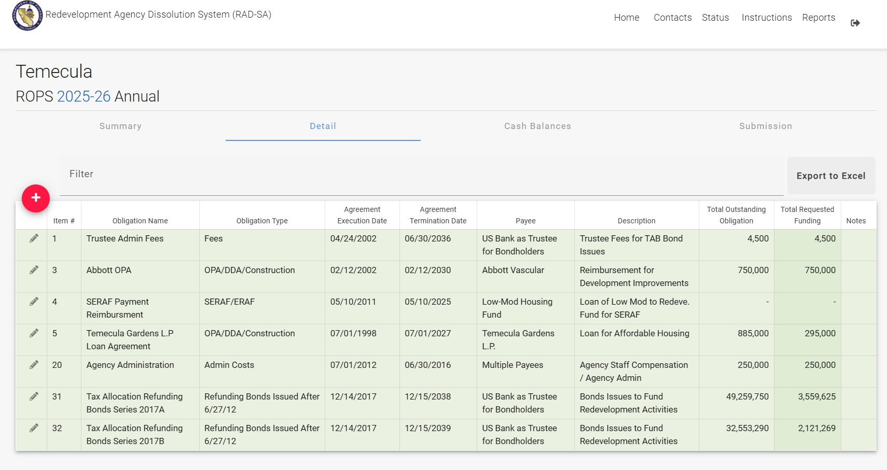
Cash Balance Report
